LINUX COMMANDS FROM TECH IT FACTORY
ADDING USER AND PASSWORD AUTHENTICATION AND PROVIND SUDO ACCESS
CONNECT TO EC2 IN GITHUB
STEP: 1 CHANGE TO ROOT USER
Command : sudo su –
Step 2: useradd techie
Step 3: give password
Command : passwd techie
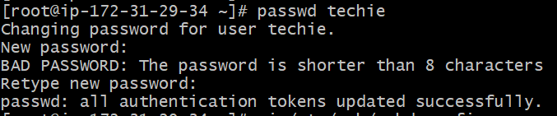
Step 4: to provide password authentication
Command : vi /etc/sshd/sshd_config
or we can use directly for providing sudo access
Command : usermod -aG sudo techie
Remove # and password authentication as yes
Step5: to access sudoers file for providing sudo access
Command : visudo
In that add techie ALL=(ALL) NOPASSWD: (ALL)

Then save using :wq!
Step :6 Then restart the service using
Command: systemctl restart sshd
Step:7 exit from root and exit from ec2
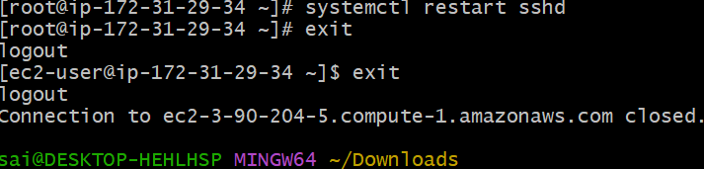
Connect the new techie user to ec2
Command : ssh techie@ec2-ipaddress
Then type password and you will be connected with techie user
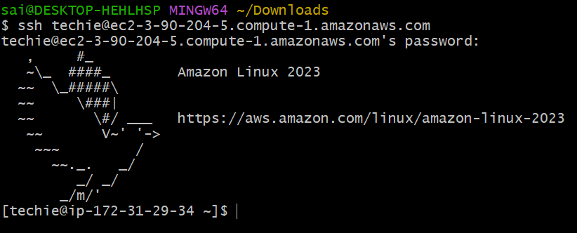
Given sudo access
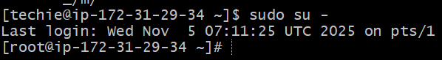

- Command name and then tab tab
Then it wil display the commands related to name
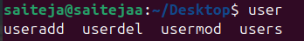

- Command : free, free-m and free-h
Free will display free and utilized space in machine
Free -m will display in mb
Free -h will display in human understandable language
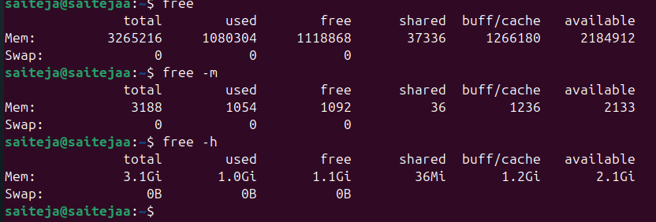

- Command : ps aux displays all processes from all users including background ones in detailed
Ps : processes

a :Show processes for all users (not just your own).
u :Display the output in user-oriented format (includes username, CPU%, MEM%, etc.).
x :Include processes not attached to a terminal (e.g., background daemons like Tomcat or nginx).

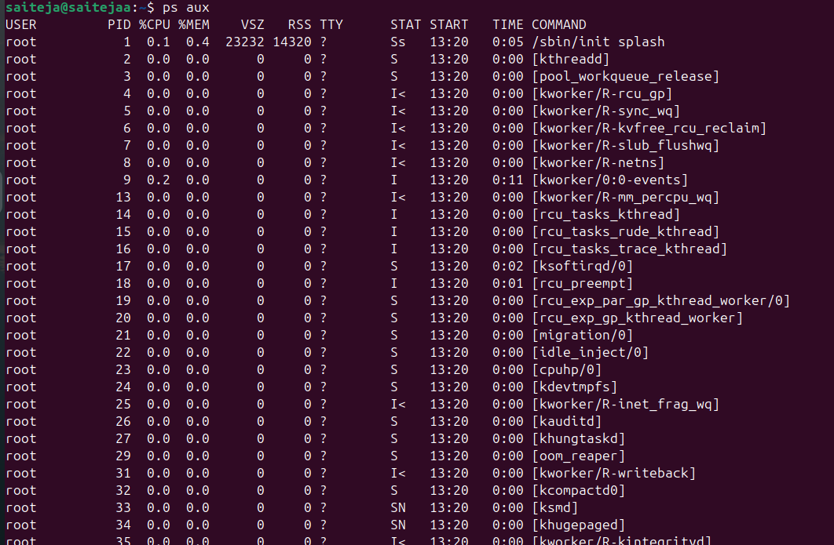
- Command :
Ctrl+r : reverse search using history
We can execute previously executed commands
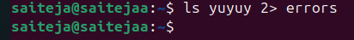
- Command pipe (|) : it provides the output of first command to input of second command
Ex: ps aux | wc
Displays the word count in ps aux means processes
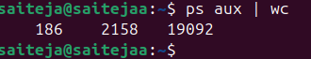
Command wc : word count
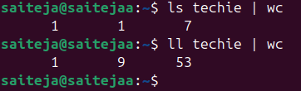

Command: (>) means over write or redirects the data
Ex: old data will be deleted and new data is stored
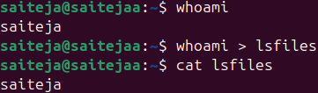
Command : (>>) means append the data or add the data
Ex: new data is added into old data
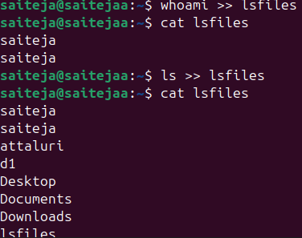

Command: ls hbfdjh
Output: no such file or directory found
If we add ls hbfdjh 2> errors
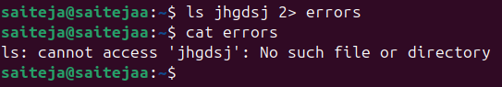
The above command the error out put will be transferred to error location
Or we can use /dev/null (it is also called as trash)
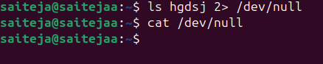
The data is not stored in null or in machine the error message will be permanently moved into trash
Command: ls * jhdsj 2> errors
If we use this above command it display correct output and error will be sent to errors or
trash
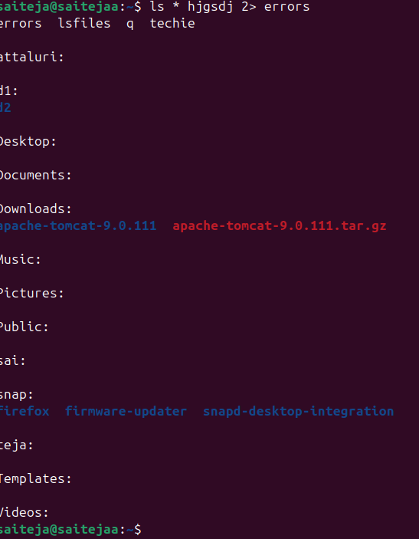
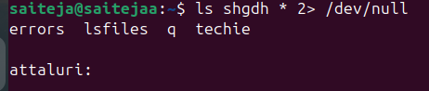
If we don’t use * then it display the output with error message
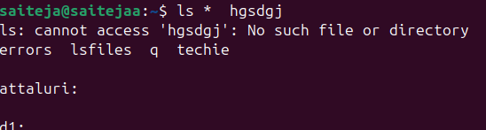

Environmental variables:.
Command : env
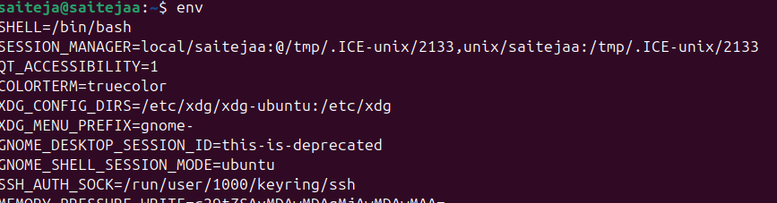
See less or page by page then
Command : env | less
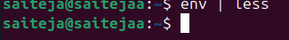
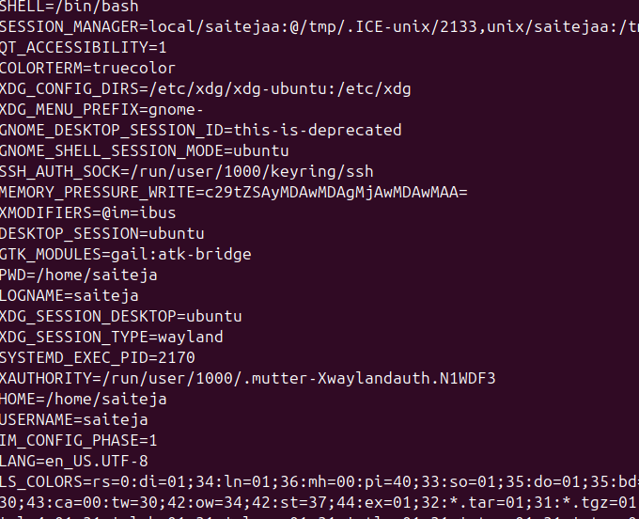

Command : alias means commands shortcuts (temporary) if we log out and log in it will gets changed
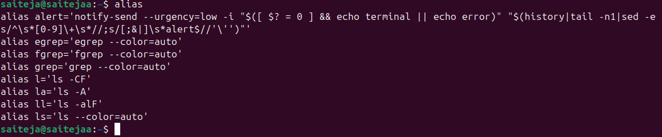

For example if we need to list files of using find / -name filename /etc/ then it will show lot of things related to etc files and for some output we get permission denied
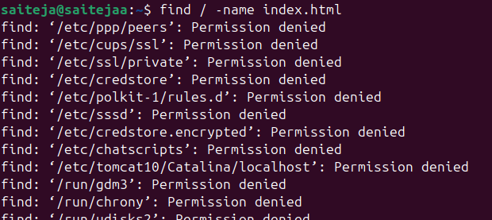
If we need only output except permission denied files the add 2> /dev/null to send all error files into null
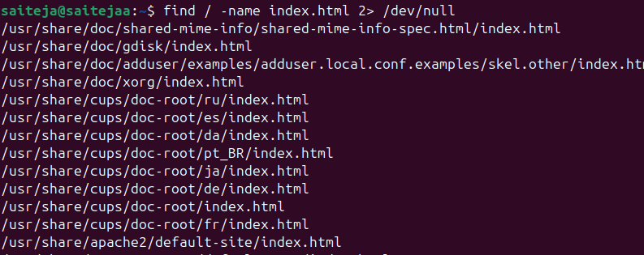

To check system logs
/var/log/messages

